Design Model Report of
Tutor Online
Version <1.0.0>

Prepared by
Group Name: 10

Nguyễn Hữu Hồng | K59CA
Trần Như Thuật | K59CA
Trần Trịnh Bình Thành | K58CA
Trần Văn Liên | K59CA

Instructor: | Dr. Dang Duc Hanh
Course: | Software Engineering 2016
Date: | 04/12/2016

Introduction

1.1 Purpose
The purpose of this report is to present a detailed description on the Design Model of the Tutor Online Website System. This document is intended for both the stakeholders and the developers of the system.

1.2 References
The report was completed following the book and documentation recommended and provided by Dr. Dang Duc Hanh including:
- The textbook Software Engineering 9th Edition written by Sommerville
- The series of lectures and slides of Software Engineering Course 2016 provided by Dr. Dang Duc Hanh.

Design Model

2.1 Identify the object classes in the system

From the requirements documenting steps, we determine what is the object classes in the tutor online system. Then, we also identify the attributes and operations or methods for each class from the description of the system requirements documentation.

There are totally 6 object classes of the Typing Tutor system shown in the following figures.

User | Profile | Subject | District | City | Time
- id  - name  - email  - password | -id  -name  -email  -phone1  -phone2  -facebook  -gender  -birthday  -job  -address  -school  -bio  -linkAvatar  -linkVideo  -active  -price | -id  -name | -id  -name | -id  -name | -id  -day  -session
+ profile() | +user()  +subjects()  +times()  +districts()  +city() | +profiles() | +profiles()  +city() | +districts()  +profiles() | -profiles()

2.2 Choose the design model.
In this project, we harness the design models in our system for showing the associations and relationships between the object classes in the system. The design model utilized in this project is sequence model, which describe the dynamic structure of the system and show the interactions between the system objects. The model is the bridge connecting the system requirements and the implementation of the project together.

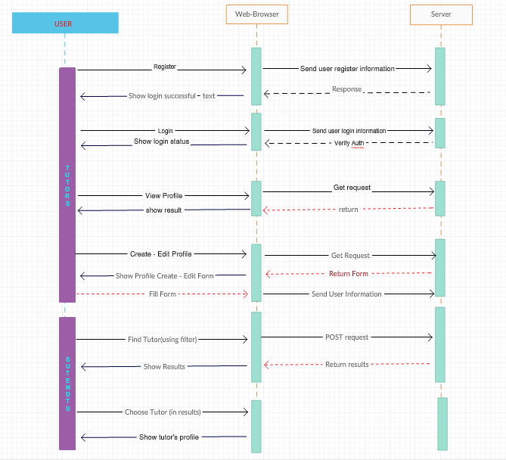

2.2.1 The use case: Register
Description of Use Case:
The tutor fill in email field and set new password to register, data will send be to sever to process, and server will check some rules (password at least 6 characters,….) and save to the database if no errors, and reponse the status to the user

2.2.2 The use case login:
Description of Login:
The tutor fill in email and password field, data will be send to the sever to verify, sever will return the result of the login session to the user

2.2.3 View Profile
Description of View Profile:
The tutor want to view his profile to answer new question or view other comments on his profile, get request will be sent to the sever, sever will get data from database via Profile Model and pass that data to the View Profile view, this view will be render to show in the browser

2.2.4 Create/ Edit Profile:
Description of Create/ Edit Profile:
The tutor has no profile, he can create new profile in the system, or if he already has a profile, the tutor can edit profile, a get request will be sent to the sever and sever respond Edit Profile view to show it to the tutor. After the the tutors will fill in the form, using some javascript code to validate input here, if no errors the results will be sent to the sever to Profiles controller and data will be save in the database

2.2.5 Find Tutor

Description of Create/ Edit Profile:
The students or parents will find suit users by using filter, this data will go to the Page Controller and get results from the database, this results will be passed to FindTutor view and render to show to the user in the grid. The result of each profile will contains the infomations for that profile in the return view in modal. The user will click on the profile to atrieve informations and comment to show exp or emotion.

